Implementation of Naïve Bayes Classification for Bank Loan Prediction
Aim
To implement the Naïve Bayes Classification algorithm in Python for predicting whether a bank loan will be approved based on customer details.

Apparatus Required
- Google Colab / Jupyter Notebook
- Python 3
- Libraries:
  - NumPy
  - Pandas
  - Scikit-learn (sklearn)

Theory
Naïve Bayes is a supervised machine learning classification algorithm based on Bayes' Theorem. It assumes that all input features are independent of each other given the class label. It is widely used for prediction tasks such as loan approval, spam detection, and medical diagnosis.
In this experiment, the model predicts whether a customer's loan will be approved based on features such as Income, Age, Credit Score, and Loan Amount.

Algorithm
- Import the required libraries.
- Create a sample bank loan dataset.
- Split the dataset into training and testing sets.
- Train the Gaussian Naïve Bayes classifier.
- Predict the loan approval status.
- Calculate the Accuracy.
- Display the Confusion Matrix and Classification Report.

Code (Google Colab)
import pandas as pd
from sklearn.model_selection import train_test_split
from sklearn.naive_bayes import GaussianNB
from sklearn.metrics import accuracy_score, confusion_matrix, classification_report

# Sample Bank Loan Dataset
data = {
'Age': [25,35,45,30,50,28,40,38,29,55],
'Income': [25000,50000,70000,30000,90000,35000,80000,60000,40000,100000],
'CreditScore': [600,700,750,620,800,650,780,720,680,820],
'LoanAmount': [100000,150000,200000,120000,250000,130000,220000,180000,140000,300000],
'LoanApproved': [0,1,1,0,1,0,1,1,0,1]
}

df = pd.DataFrame(data)

# Features and Target
X = df[['Age', 'Income', 'CreditScore', 'LoanAmount']]
y = df['LoanApproved']

# Split dataset
X_train, X_test, y_train, y_test = train_test_split(
X, y, test_size=0.3, random_state=42
)

# Train Naïve Bayes model
model = GaussianNB()
model.fit(X_train, y_train)

# Predict
y_pred = model.predict(X_test)

# Results
print("Actual Loan Status:")
print(y_test.values)

print("\nPredicted Loan Status:")
print(y_pred)

print("\nAccuracy:")
print(accuracy_score(y_test, y_pred))

print("\nConfusion Matrix:")
print(confusion_matrix(y_test, y_pred))

print("\nClassification Report:")
print(classification_report(y_test, y_pred))

Sample Output
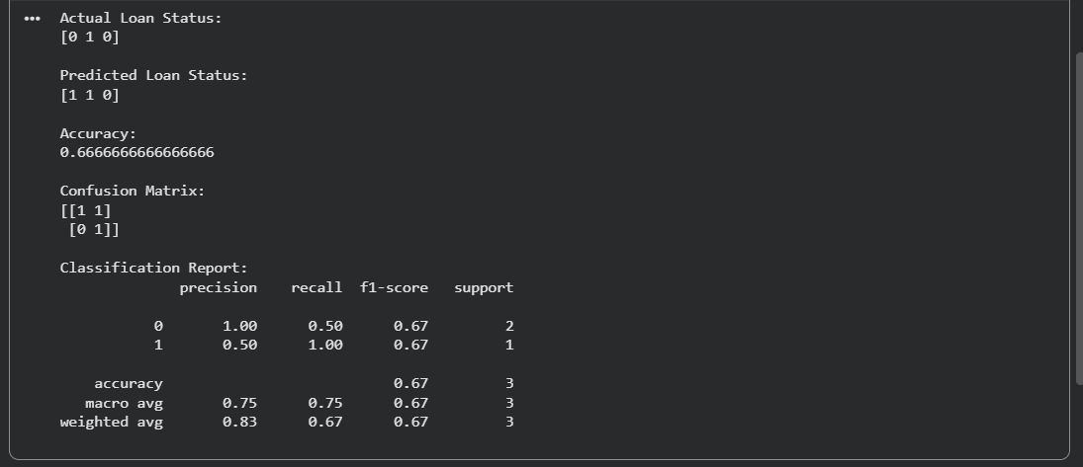
Result
The Naïve Bayes Classification algorithm was successfully implemented for Bank Loan Prediction in Python. The model predicted whether a loan would be approved or not approved based on customer information, and its performance was evaluated using Accuracy, Confusion Matrix, and the Classification Report.

